LIBRARY LESSON PLANS  DATE: September 17-21, 2018  TEACHER: J. Densford | GRADE LEVELS: (circle one)  K/1, 2/3, 4/5
TOPIC: | Author or Illustrator?
STANDARDS: | CCSS.ELA-LITERACY.RL.K.3  With prompting and support, identify characters, settings, and major events in a story.  CCSS.ELA-LITERACY.RL.1.1  Ask and answer questions about key details in a text.  CCSS.ELA-LITERACY.RL.1.7  Use illustrations and details in a story to describe its characters, setting, or events.
BOOK READ ALOUD: | Froggy Goes to School  Froggy Goes to the Doctor  -Jonathan London
ITEMS NEEDED FOR LESSON: | 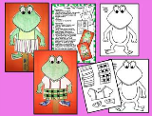  Color Froggy’s outfit and pass back to me for next week.
LESSON LAYOUT: | After read aloud we will go over the difference between an author and an illustrator. Then we will watch a short video from Sesame Street on what an author is. Last, kids will choose and color the outfit they want to dress Froggy in while we are checking out books.  Word on the Street: Author Video  http://viewpure.com/gECUFhqoULI?start=0&end=0

LIBRARY LESSON PLANS  DATE: September 17-21, 2018  TEACHER: J. Densford | GRADE LEVELS: (circle one)  K/1, 2/3, 4/5
TOPIC: | Fiction or Nonfiction?  Book Connections - Text to Self, Text to Book, Text to World
STANDARDS: | CCSS.ELA-LITERACY.RL.2.1  Ask and answer such questions as who, what, where, when, why, and how to demonstrate understanding of key details in a text.  CCSS.ELA-LITERACY.RL.2.3  Describe how characters in a story respond to major events and challenges.  CCSS.ELA-LITERACY.RL.3.6  Distinguish their own point of view from that of the narrator or those of the characters.
BOOK READ ALOUD: | Lilly’s Purple Plastic Purse  -Kevin Henkes
ITEMS NEEDED FOR LESSON: | Text to book, text to self, text to world form
LESSON LAYOUT: | After read aloud, we will review the difference between fiction and nonfiction. I will share some of the books they looked at last week as reminders of the difference. Then I will introduce 3 different ways you can connect to text: text to another book, text to yourself, text to world. While checking out students will fill out reflection sheet and share 3 ways they connected to the book we read today.

LIBRARY LESSON PLANS  DATE: September 17-21, 2018  TEACHER: J. Densford | GRADE LEVELS: (circle one)  K/1, 2/3, 4/5
TOPIC: | What is historic fiction?  Theme - discuss what a theme is by using some common stories like Little Red Riding Hood or Cinderella.  Narrator - how does it change how events are discussed
STANDARDS: | CCSS.ELA-LITERACY.RL.4.2  Determine a theme of a story, drama, or poem from details in the text; summarize the text.  CCSS.ELA-LITERACY.RL.5.6  Describe how a narrator's or speaker's point of view influences how events are described.
BOOK READ ALOUD: | Baseball Saved Us  -Ken Mochizuki  (Japanese internment during WW II)
ITEMS NEEDED FOR LESSON: | 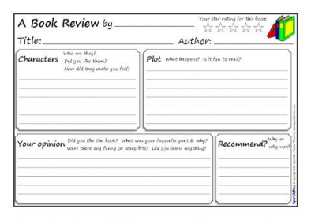
LESSON LAYOUT: | After read aloud, we will quickly review what historic fiction is. Then we will move on to discuss themes of books. As an example I will use common stories that most children should already know. After I feel that students have a grasp, I will see if we can figure out the theme of the book we read aloud together. Last, we will discuss how different narrators of the same story can change the view of events. (This story was told by a child in the internment camp. Yet, many Americans felt nothing wrong was done when these Asian Americans were locked up.) Students will fill out book review while we check out.

