LIBRARY LESSON PLANS  DATE: September 10-14, 2018  TEACHER: J. Densford | GRADE LEVELS: (circle one)  K/1, 2/3, 4/5
TOPIC: | Parts of a Book
STANDARDS: | CCSS.ELA-LITERACY.RL.1.1  Ask and answer questions about key details in a text.  CCSS.ELA-LITERACY.RL.1.7  Use illustrations and details in a story to describe its characters, setting, or events.  CCSS.ELA-LITERACY.RL.K.3  With prompting and support, identify characters, settings, and major events in a story.
BOOK READ ALOUD: | Froggy Goes to Camp  Froggy Learns to Swim  -Jonathan London
ITEMS NEEDED FOR LESSON: | 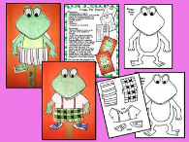  Color froggy puppet and pass back to me for next week
LESSON LAYOUT: | - After read aloud, watch short video on “Parts of a Book” - http://viewpure.com/cu8j7YnunzQ?start=0&end=0  - Then have students go to tables and color their froggy puppet, put their name on it, and return it to me for next week.  - Last, play “Simon Says” Parts of a Book to help students explore the parts of a real book.

LIBRARY LESSON PLANS  DATE: September 10-14, 2018  TEACHER: J. Densford | GRADE LEVELS: (circle one)  K/1, 2/3, 4/5
TOPIC: | Parts of a Book  Author or Illustrator?
STANDARDS: | CCSS.ELA-LITERACY.RL.3.1  Ask and answer questions to demonstrate understanding of a text, referring explicitly to the text as the basis for the answers.  CCSS.ELA-LITERACY.RL.2.1  Ask and answer such questions as who, what, where, when, why, and how to demonstrate understanding of key details in a text.  CCSS.ELA-LITERACY.RL.2.3  Describe how characters in a story respond to major events and challenges.
BOOK READ ALOUD: | Chrysanthemum  -Kevin Henkes
ITEMS NEEDED FOR LESSON: | 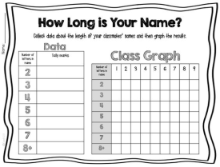  Tally letters in book character’s name, your own, and at least 1 friend at their table. Then graph your results.
LESSON LAYOUT: | - After read aloud, review orally parts of a book.  - The review what authors and Illustrators do by watching short video-  - http://viewpure.com/un5c1zS2fgs?start=0&end=0  - Last, have students go to their table and pass out “How Long is Your Name?” sheets. Students will tally the letters in Chrysanthemum’s name, their own, and the friends at their table if time allows.

LIBRARY LESSON PLANS  DATE: September 10-14, 2018  TEACHER: J. Densford | GRADE LEVELS: (circle one)  K/1, 2/3, 4/5
TOPIC: | Review: Parts of a Book and Author or Illustrator? and Fiction or Nonfiction  Introduce: historic fiction
STANDARDS: | CCSS.ELA-LITERACY.RL.4.3  Describe in depth a character, setting, or event in a story or drama, drawing on specific details in the text (e.g., a character's thoughts, words, or actions).  CCSS.ELA-LITERACY.RL.5.5  Explain how a series of chapters, scenes, or stanzas fits together to provide the overall structure of a particular story, drama, or poem.  CCSS.ELA-LITERACY.RL.5.6  Describe how a narrator's or speaker's point of view influences how events are described.
BOOK READ ALOUD: | (focus on historical fiction picture books)  More Than Anything Else  -Marie Bradby  (African American history/Slavery)
ITEMS NEEDED FOR LESSON: | 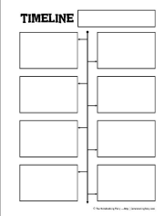  Students will create a timeline using words and sketches on the book we read aloud.
LESSON LAYOUT: | - After read aloud, we will review parts of a book and author or illustrator and fiction or nonfiction briefly.  - During this time we will also review the story elements of the book that was just read aloud.  - I will introduce historic fiction and students will be able to pick out the historic elements.  - Last, students will go to their table and sketch events from the book in order. I will post a list of 8 short events to put in order.

