LIBRARY LESSON PLANS  DATE: August 27-31, 2018  TEACHER: J. Densford | GRADE LEVELS: (circle one)  K/1, 2/3, 4/5
TOPIC: | Book Care
BOOK READ ALOUD: | The Cow That Was the Best Mooo-ther  -Andy Cutbill
ITEMS NEEDED FOR LESSON: | 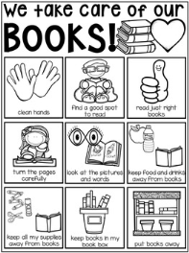  Book Care Coloring Poster
LESSON LAYOUT: | - After read aloud, teacher will go over book care rules:  - Don’t write, color, or cut books  - Don’t fold pages back  - Don’t take books outside or around water  - Keep books up for little kids and pets  - Treat books like a baby!  - Students will be ask why they think each rule is important and be given time to color the book care poster.  - Students will watch short video called What Happened to Marion’s Book at http://viewpure.com/JZWP-JVML9M?start=0&end=0  - Teacher will introduce the song “I treat my book like a baby everyday (pat) (pat)” and students will practice singing it.

LIBRARY LESSON PLANS  DATE: August 27-31, 2018  TEACHER: J. Densford | GRADE LEVELS: (circle one)  K/1, 2/3, 4/5
TOPIC: | Book Care
BOOK READ ALOUD: | Monster Boy’s School Lunch  -Carl Emmerson
ITEMS NEEDED FOR LESSON: | 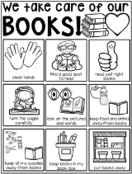  Book Care Coloring Poster
LESSON LAYOUT: | - After read aloud, teacher will go over book care rules:  - Don’t write, color, or cut books  - Don’t fold pages back  - Don’t take books outside or around water  - Keep books up for little kids and pets  - Treat books like a baby!  - Students will be ask why they think each rule is important and be given time to color the book care poster.  - Students will watch short video called What Happened to Marion’s Book at http://viewpure.com/JZWP-JVML9M?start=0&end=0  - Teacher will introduce the song “I treat my book like a baby everyday (pat) (pat)” and students will practice singing it.

LIBRARY LESSON PLANS  DATE: August 27-31, 2018  TEACHER: J. Densford | GRADE LEVELS: (circle one)  K/1, 2/3, 4/5
TOPIC: | Book Care
BOOK READ ALOUD: | 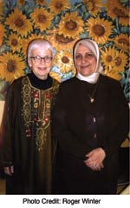  The Librarian of Basra  -Jeanette Winter
ITEMS NEEDED FOR LESSON: | 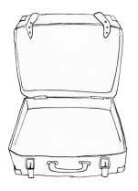  - If you suddenly had to pack up and leave and were never going to return, what would you take?  - Draw between 3-5 items in your suitcase.  - On the back write a sentence for each item explaining your reasoning.
LESSON LAYOUT: | - After read aloud, teacher will show the students an actual photo of the character in the book.  - Then review book care rules; with emphasis on taking books outside, eating lunch while reading, leaving books by bathroom and water fountain, folding pages back instead of using a bookmark, and RETURNING BOOKS IN A TIMELY MANNER so others can read them.

