LIBRARY LESSON PLANS  DATE: August 20-24, 2018  TEACHER: J. Densford | GRADE LEVELS: (circle one)  K/1, 2/3, 4/5
TOPIC: | Library Rules
BOOK READ ALOUD: | First Week at Cow School  -Andy Cutbill
ITEMS NEEDED FOR LESSON: | 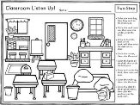  Classroom Listen Up - following oral directions (one step, level one)
LESSON LAYOUT: | - Before read aloud, teacher will use the “Making prediction before reading” sheet (from TPT) and demonstrate how to take a picture walk to predict what the story is about.  - During read aloud, teacher will use the “Using the Illustrations” sheet (from TPT) to demonstrate how to look at illustrations to help you figure out what is happening.  - After read aloud, the librarian will briefly go over library rules: listen, walk, clean up, use good manners.  - Last, the teacher will pass out and read aloud the oral directions for students to follow on a classroom picture.

LIBRARY LESSON PLANS  DATE: August 20-24, 2018  TEACHER: J. Densford | GRADE LEVELS: (circle one)  K/1, 2/3, 4/5
TOPIC: | Library Rules
BOOK READ ALOUD: | Monster Boy at the Library  -Carl Emmerson
ITEMS NEEDED FOR LESSON: | 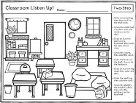  Classroom Listen Up - following oral and written directions. (two step, level one)
LESSON LAYOUT: | - After read aloud, the librarian will go over library rules: listen, walk, clean up, use good manners, raise your hand if you need help (but not during read aloud), blue line is silent line, return books on time.  - Then students will go to library tables and receive a worksheet that pictures a classroom illustration.  - Last, teacher will instruct students to read the two step directions and follow what each one says. Also, we will briefly discuss how important good listening is.

LIBRARY LESSON PLANS  DATE: August 20-24, 2018  TEACHER: J. Densford | GRADE LEVELS: (circle one)  K/1, 2/3, 4/5
TOPIC: | Library Rules
BOOK READ ALOUD: | Miss Dorothy and Her Bookmobile  -Gloria Houston
ITEMS NEEDED FOR LESSON: | 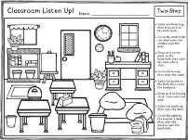  Classroom Listen Up - following oral and written directions. (two step, level two)
LESSON LAYOUT: | - After read aloud, the librarian will go over library rules: listen, walk, clean up, use good manners, raise your hand if you need help (but not during read aloud), blue line is silent line, return books on time.  - Then students will go to library tables and receive a worksheet that pictures a classroom illustration.  - Last, teacher will instruct students to read the two step directions and follow what each one says. Also, we will briefly discuss how important good listening is.

