FIRST WEEK OF SCHOOL
LIBRARY LESSON PLANS  DATE: August 13-17, 2018  TEACHER: J. Densford | GRADE LEVELS: (circle one)  K/1, 2/3, 4/5
TOPIC: | Getting to Know You
BOOK READ ALOUD: | The Cow That Laid the Egg  - Andy Cutbill
ITEMS NEEDED FOR LESSON: | - The Big Wind Blows - questions for game  - Marjorie the cow, coloring sheet  - Story Souvenir: plastic egg with baby chick inside
LESSON LAYOUT: | - After read aloud, teacher will have students sit at tables and color the picture of Marjorie.  - Then students will get in a large circle and play “The Big Wind Blows” using getting to know you questions.  - Last students will be given a souvenir to remember their first day of library and the story of Marjorie and her baby.

LIBRARY LESSON PLANS  DATE: August 13-17, 2018  TEACHER: J. Densford | GRADE LEVELS: (circle one)  K/1, 2/3, 4/5
TOPIC: | Getting to Know You
BOOK READ ALOUD: | Monster Boy’s First Day of School  -Carl Emerson
ITEMS NEEDED FOR LESSON: | 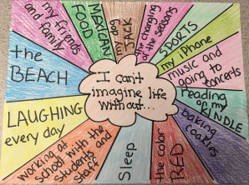  White construction paper, markers, crayons
LESSON LAYOUT: | - After read aloud, students will be seated at tables and given a white piece of paper.  - Next they will use a marker to create a bubble in the center and write “I can’t imagine life without”, as seen in picture.  - Then students will write 4-8 items around the bubble writing things they can’t live without. I.e. cheeseburgers, their dog, etc…  - Last students will color each section a different shade of crayon as teacher introduces herself and discusses the year.

LIBRARY LESSON PLANS  DATE: August 13-17, 2018  TEACHER: J. Densford | GRADE LEVELS: (circle one)  K/1, 2/3, 4/5
TOPIC: | Getting to Know You
BOOK READ ALOUD: | That Book Woman  -Heather Henson
ITEMS NEEDED FOR LESSON: | 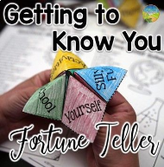  Copies of “Getting to Know You” fortune teller
LESSON LAYOUT: | - After read aloud, students will be seated at tables.  - Each student will get a copy of the “getting to know you” fortune teller and a pair of scissors.  - Students will be instructed to cut out their fortune teller, throw their trash away, and put their scissors up.  - Then the teacher will direct students in how to properly fold their fortune teller.  - Last students will be given some time to “play” with the fortune teller at their table.

